Directions: Submit the answers to each question below in a Word document. Please be sure to label each question. Please be sure to cite any sources.

1)
When a jury decides whether or not a defendant is guilty, do they collectively use primarily inductive reasoning, deductive reasoning, or an equal amount of each? Write a paragraph supporting your answer. Use specific examples to support your thinking.

2)
Identify two ways that you use estimation in your daily life. Discuss each of them in a paragraph and give examples.

3)
Use the last digit of your phone number and create a Set A with that number of elements. Write your set using Roster Form. Identify the cardinality of your Set A using the correct notation. Identify the number of subsets and proper subsets of your Set A. Write a sentence or paragraph explaining the difference between the number of subsets and proper subsets.

4)
Use the Nielsen Top 10 Lists website
Nielsen Top 10 Lists
to create a Venn diagram. Find the data on Video Games – Worldwide Digital Games Market. Create a Venn diagram illustrating the ten top rank PC games and the ten top console games.

Label the two circles for the two categories of data. You may want to first list the data (names of games) separately, then arrange those data items on the Venn diagram template as appropriate.

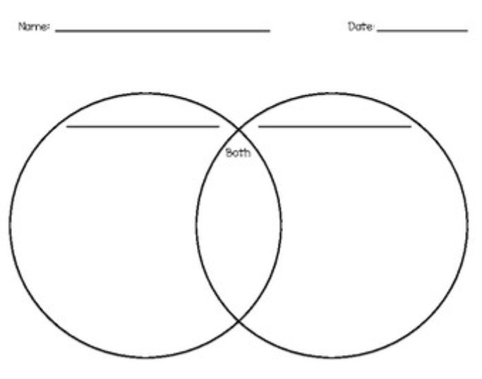

5) (data list; diagram = )
Take a poll among 20 of your friends, family, business associates, or social media subscribers. Ask each person two question: A) Do you enjoy watching action movies? B) Do you enjoy watching documentary movies? Record your results in an organized list. See attachment A for an example. Complete the two-set Venn diagram template with numbers that represent your results. Label your diagram and each set. Be sure to include the number of people who may not enjoy either of those types of movies.
You can copy and paste the Venn Diagram outline below into your document and resize it as you need.

6)
Write one of each of the following statements. They must be entirely unique, not from the textbook, the internet, or class examples. Include examples that are relevant to you.
- A statement using a conjunction and tell how you know when that statement is true.
- A statement using a negation.
- A statement using a disjunction.
- A conditional statement and tell how you know when that statement is false
- A biconditional statement
- A statement that contains a quantifier and the negation of that statement

7)
Write a paragraph about the relationship between “negation” in logic and “complement” in set theory.

8)
Show how logic is used in advertising. Discuss two or three advertisements shown in Appendix B and discuss how logic is used to persuade the reader. Write a conditional statement that is implied by one of the advertisements that you use.

9)
Construct a system of two linear equations that has no solution. In a paragraph, explain how you know that the system has no solution. Also provide a statement that tells what it means not to have a solution.

Appendix A
Person | Do you like Action Movies | Do you like Documentaries
1 | Yes | Yes
2 | No | Yes
3 | No | No
4 | No | Yes
Etc.
Etc.
20 | Yes | No

Appendix B Advertisements

