Final Assessment Outline

Competency Name: Operations Management

Competency Statement: Develop an understanding of the role of operations management in business.

Final Assessment Title: Operations Management Case Study Analysis

Program Learning Outcomes: PLO 1 – Communication: Demonstrate effective oral and written
communication skills in organizational and professional settings.

Institutional Learning Outcomes: N/A

Competency Objectives

- Develop an understanding of production processes, quality control, costs, and other techniques for maximizing the effective manufacture and distribution of goods.
- Develop an understanding of the tools used to implement continuous process improvement (e.g., benchmarking systems, process mapping, process costing, maturity models, capability maturity model, contract management maturity model, process improvement metrics, process improvement methods, and supplier workshops) in accordance with organizational objectives.
- Develop an understanding of optimization and resource management tools (e.g., inventory control, scheduling, TQP, and MRP).

Purpose of This Assessment

The purpose of this final assessment is to assess your ability to accurately analyze and apply operations management theories. You will act as if you have been hired as a consultant to analyze and present recommendations to Corus’ (a steel manufacturing company) operations management practices. Assume you will present your recommendations to the Corus’ Board of Directors for implementation within the next week. Your presentation must demonstrate how well you apply operations management theories, including 1) distribution of goods, 2) continuous process improvement, 2) resource management, and 4) current practices. You must also include an analysis of strengths and weaknesses of Corus’ five-year plan as outlined in the case study provided, along with your personal and/or professional experiences related to the operations management theories discussed.

Items Required for Submission

The item required for submission is a seven- to 15-minute PowerPoint presentation with voiceover.

Step 1: Preparation

To prepare for this assignment, read the case study and make a list of the strengths and weaknesses of current plans and practices apparent in the study.

Step 2: Completing the PowerPoint Presentation with Voiceover

Now complete your PowerPoint presentation with voiceover. To learn how to apply the voiceover, watch this video:
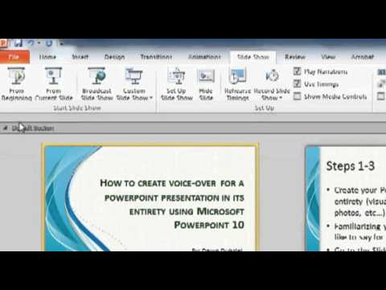

Apply at least five scholarly sources to support the claims you make in your presentation. Use competency materials as a resource. Include the following in your presentation:

  - An accurate analysis of the strengths and weaknesses of current plans and practices of the mill as they relate to the operations management theories of distribution of goods, management of resources, continuous process improvement, and current practices.
  - Personal and/or professional experiences as they relate to the operations management theories, either as a consumer or on the job. For example, prepare to discuss your own experience on a continuous improvement team, or as a consumer trying to purchase an out-of-stock item or purchased items delivered late.
  - A plan of recommendations to change Corus’ distribution strategy, continuous improvement, and resource management that clearly address the weaknesses you analyzed in the Corus case study.
  - An implementation schedule you are recommending to put your proposed changes into action over the next two weeks. Ensure that suggestions relate to distribution of goods, management of resources, and continuous process improvement.
  - Accountability plan (a breakdown of managers’ and employees’ responsibilities) to put your proposed changes into action. Include what additional tools Corus can use to measure productivity. Ensure that suggestions relate to distribution of goods, management of resources, and continuous process improvement.

The presentation must:

  - Apply at least five scholarly sources to support your analysis, cited in APA format.
  - Include 15 to 20 slides that support and reinforce key points.
  - Be comprehensive, interesting, and flow logically, fully addressing key points.
  - Include critical points with visuals that are creative, interesting, and easy to read.
  - Use correct grammar and spelling without errors.
  - Be delivered professionally, in a way that would be favorably received by a Board of Directors.

Step 3: Complete Checklist for Submission

Before you submit, check to see if you believe you have met the criteria noted below. Did you….
- Appropriately explain concepts in your own words?
- Communicate a clear understanding of operations management practices (including distribution of goods, management of resources, continuous process improvement, and current practices)?
- Ensure the content of your presentation is thoughtful and accurate with no factual errors?
- Engage the audience with excellent analysis (including strengths) and personal discussion/examples regarding the distribution of goods, management of resources, and continuous process?
- Demonstrate an understanding and apply weaknesses to synthesize recommendations in a thoughtful and meaningful way?
- Ensure your schedule and accountability plans are logically addressed?
- Support your presentation with at least five outside sources and cite all your sources in APA?
- Ensure your writing is logical and organized? Are your sentences well-phrased and varied in length and structure? Is your word choice consistently precise and accurate?
- Make certain your writing is free of grammatical, spelling, and mechanical errors while following the specified length?
- Check that your citations and reference pages are correct?
- Ensure your presentation is comprehensive, interesting, flows logically, fully addresses key points, and consistently connects with visuals?
- Use visuals that are creative, visually interesting, and easy to read, as well as emphasize critical points of the presentation?

Step 4: Submit Your Work
- Your completed final assessment documents should be submitted through the Final Assessment page of your competency.
- Please note, for files smaller than 10MB (i.e., most Word documents), use the corresponding “+UPLOAD STUDENT FILE” button to upload your final assessment assignments. For larger files of any type (i.e., voice-over PowerPoint files, videos, or image-heavy documents), please use the optional TEXT EDITOR to provide a URL where your grader can download your file.

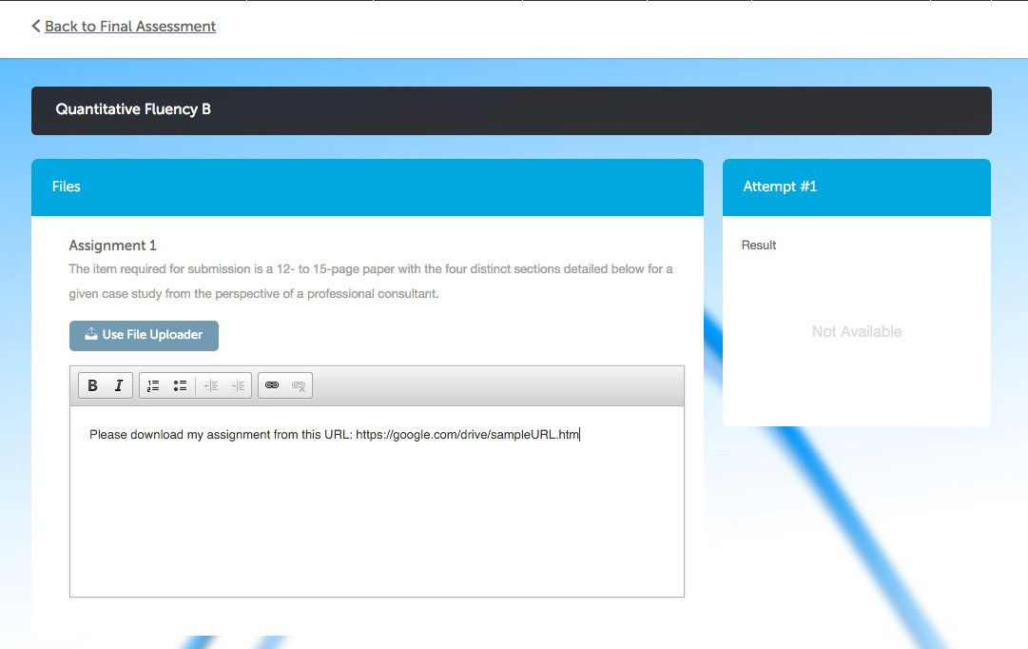
- How you create a download URL is up to you, but various free online providers, including Google Drive, Box.com, or Dropbox, offer this service. Please make sure that the URL you provide can be accessed by anyone with the link. For further instructions on how to create public links for uploaded files, consult the support pages for your chosen provider.

Final Assessment Rubric

Criterion | EMERGING – 1 | DEVELOPING – 2 | PROFICIENT – 3 | EXEMPLARY – 4
Professional and Personal Experiences | The presentation content is confusing or contains more than one factual error. Does not apply Operations Management practices appropriately. The analysis and personal discussion/examples of the distribution of goods, management of resources, and continuous process improvement are unclear. | The content of the presentation is generally accurate, but one piece of information is clearly inaccurate. Applies some terminology and concepts appropriately. The analysis and personal discussion/examples of the distribution of goods, management of resources, and continuous process are somewhat unclear. | Most of the presentation content is accurate, but there is one piece of information that seems confusing. Applies most terminology and concepts appropriately. Creates a somewhat clear analysis and personal discussion/examples of the distribution of goods, management of resources, and continuous process. | The content of the presentation is thoughtful and accurate. A good blending of outside sources and personal experiences. There are no factual errors.  Applies terminology and concepts appropriately. Engages excellent analysis and personal discussion/examples regarding the distribution of goods, management of resources, and continuous process.
Understanding  Critical Concepts within | Does not communicate understanding of operations management practices (including distribution of goods, management of resources, continuous process improvement, and | Communicates some understanding of operations management practices or concepts (including distribution of goods, management of resources, continuous process | Communicates a solid understanding of operations management practices (including distribution of goods, management of resources, continuous process improvement, and | Communicates a comprehensive and clear understanding of operations management practices (including distribution of goods, management

Analysis  (distribution of goods, management of resources, continuous process improvement, and current practices) | current practices). Relies on paraphrasing and quoting and does not uses theory or concepts appropriately in the assignment. | improvement, and current practices) but relies on more paraphrasing and quoting than own words and sometimes uses the theory or concepts appropriately in the assignment. | current practices) by explaining in own words and usually using the theory or concepts appropriately in the assignment. | of resources, continuous process improvement, and current practices.) Explains in own words concepts appropriately in the assignment.
Application of Theory through Strengths, Weaknesses and Recommendatio ns | Rarely or never applies operations management practices, examples, experience, and/or “real world” situations in a thoughtful or meaningful way. Does not take theory beyond traditional applications. | Sometimes applies operations management theory to practice, examples, experience, and/or “real world” situations, but it is not always thoughtful and/or meaningful. Sometimes takes theory beyond traditional applications. | Often applies operations management theory to practice, examples, experience, and/or “real world” situations in a thoughtful and meaningful manner per the assignment. Usually takes theory beyond traditional applications. | Consistently applies operations management theory to practice, examples, experience, and personal experience with the technology in a thoughtful and meaningful manner per the assignment. Takes  theory beyond
 |  |  |  | traditional applications
Supporting | Appropriately applies less | Appropriately applies three | Appropriately applies five | Appropriately applies
Evidence | than three outside sources | or four outside sources to | sources to support findings. | more than five or more
 | to support findings. | support findings. |  | sources to support
 |  |  |  | findings.

Proposed Recommendatio ns | Rarely or never applies weaknesses to synthesize recommendations. | Demonstrates some understanding and applies weaknesses to synthesize recommendations. | Demonstrates adequate understanding and applies weaknesses to synthesize recommendations. | Demonstrates a comprehensive understanding and applies weaknesses to synthesize recommendations in a thoughtful and meaningful way.
Implementation Timeline(s) and Accountability Plan(s) | Schedule and accountability not addressed. | Schedule and accountability hardly addressed. | Schedule and accountability addressed, but slightly lacking. | Schedule and accountability addressed logically.
Writing and | Writing is not logical or | Writing lacks logical | Writing is generally logical, | Writing is logical, well-
Organization | organized. Words are used | progression or organization. | well-phrased, and | phrased, and organized
 | inappropriately. There are | Sentences are awkward and | organized. Word choice is | Word choice is
 | several errors in grammar, | often unclear. Word choice | generally precise and | consistently precise an
 | spelling, and writing | is acceptable but range of | mostly accurate. There are | accurate. The writing is
 | mechanics. | words is limited or lack | occasional errors in | free of errors in
 |  | precision. The writing has | grammar, spelling, and | grammar, spelling, and
 |  | errors, which impact the | writing mechanics. | writing mechanics.
 |  | understanding of the
 |  | presentation and cause a
 |  | distraction.
Presentation | The PowerPoint is shorter | The PowerPoint is shorter | The PowerPoint is the | The PowerPoint is the
 | than the specified length of | than the specified length of | specified length of the | specified length of the
 | the assignment. Limited if | the assignment. APA | assignment. APA formatting | assignment. APA
 | any adherence to APA | standards are somewhat | standards are followed with | formatting standards
 | standards. | followed but with numerous | a few minor errors. | are followed; citations
 |  | errors. PowerPoint contains | PowerPoint contains the | and reference page is

d

d
 | PowerPoint contains less than the required amount of slides. The voiceover is clearly and professionally articulated within the specified time limit. | less than the required amount of slides. The voiceover is clearly and professionally articulated within the specified time limit. | required amount of slides. The voiceover is clearly and professionally articulated within the specified time limit. | correct. PowerPoint contains the required amount of slides. The voiceover is clearly and professionally articulated within the specified time limit.
 | Visuals are confusing, | Visuals may be somewhat | Visuals are clear, easy to | Visuals are creative,
 | difficult to read, and/or | confusing and difficult to | read, and relevant to the key | visually interesting, an
Visuals | include irrelevant content. | read, and/or do not | points of the presentation. | easy to read, as well as
 |  | highlight key points of the |  | emphasize critical
 |  | presentation. |  | points of the
 |  |  |  | presentation.

Appendix: Case Study

Continuous Improvement as a business strategy

https://prod-umpi-cbeupload.s3.amazonaws.com/assets/5187/Corus - Continuous Improvement.pdf

